Networking Assignment
You are provided with a .pcap file. Import it into Wireshark, and then analyse it. Filter it for HTTP packets and then submit these:
- A screenshot of your results with your http filter.
- The link to the http url that was visited.
- The username and password entered in the website.

For those who don’t have access to a PC, you can use https://apackets.com/ , but ensure you include all required answers.

Submission Instructions.
Submit a Word document or PDF with your complete answers or a Google Docs link to your submission (ENSURE YOUR GRANT ACCESS).

Any other formats apart from these would be graded as 0.
Submission Deadline: Wednesday, 12th August, 2026, 4pm.

.pcap File: https://drive.google.com/file/d/1bfdomtSsJwO1xnc5cvB2Rkr_Clj5izns/view?usp=sharing

ANSWER
N/B :- The numbering of this work is not according to the question but according to the steps used in the explanation. Thank you for your understanding.
- Through the assignment link I was able to open the assignment .pcap file having packets of 1068 as shown below in the screenshot.
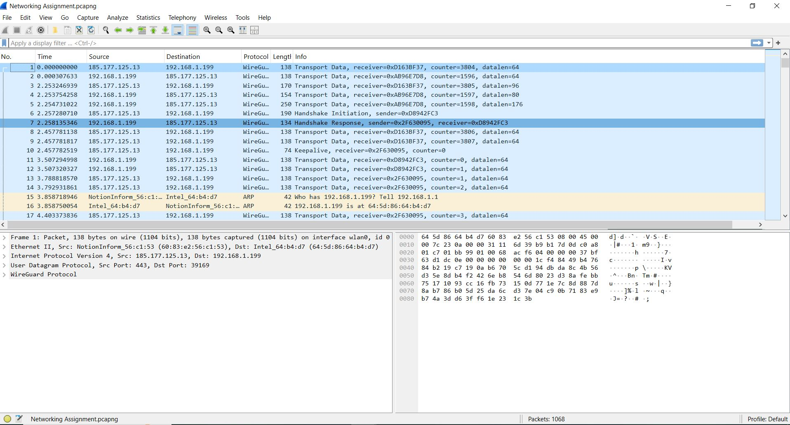

- I filtered with the http as requested showing displayed 6 (0.6%) as shown below.
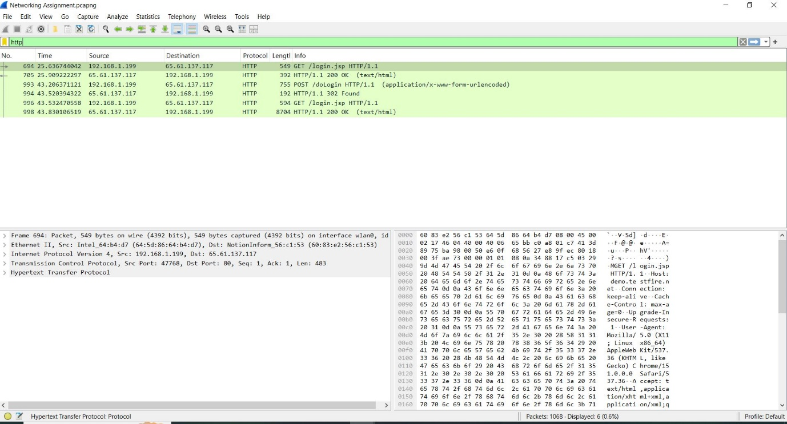

- I clicked on POST since logins normally submitted through post as shown below
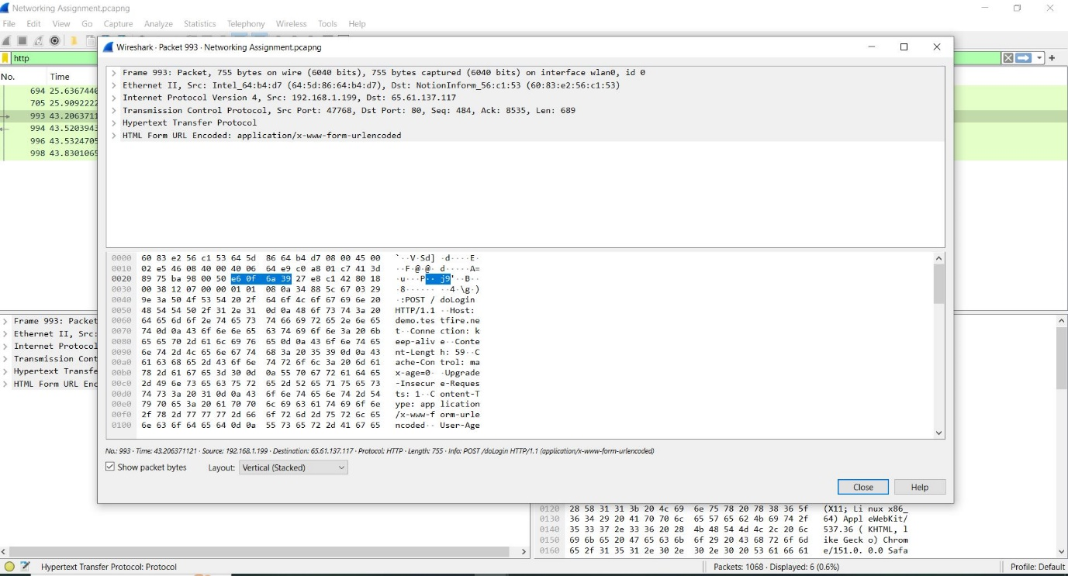

- I clicked on hypertext transfer protocol and got the URL link as http://demo.testfire.net/login.jsp\r\n as shown below
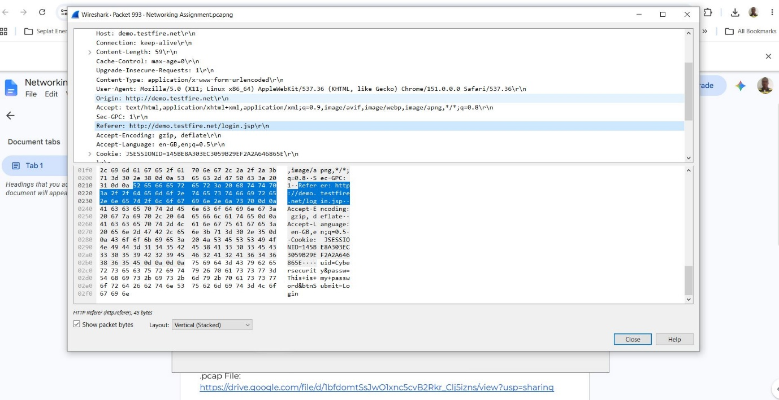

- I clicked again on HTML FORM URL ENCODED and got the Username: Cybersecurity
Password: This is my password as shown below.


